951Quiz ee01 2006.09.25
1. A bar of silicon is doped with acceptors as known below. The doping density varies smoothly and monotonically in the direction from 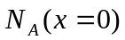 to 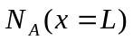, 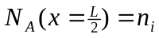. Around 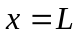 the acceptor profile becomes uniform. The donor density is zero everywhere. This is a thermal equilibrium situation.
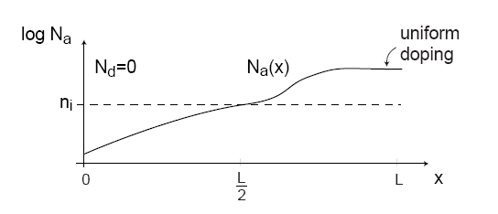
- Where is the hole concentration the greatest?
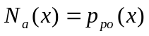 the hole concentration is greatest where 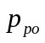 is greatest.
The answer is .
- Where is the electron concentration the greatest?
According to the mass active law 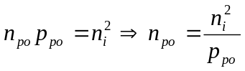. The electron concentration is greatest where the hole concentration is lowest.
The answer is .
- In which direction does the hole diffusion current flow?
The hole diffuse from right to left, so the hole diffusion current direction is 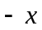.
- In which direction does the electric field point?
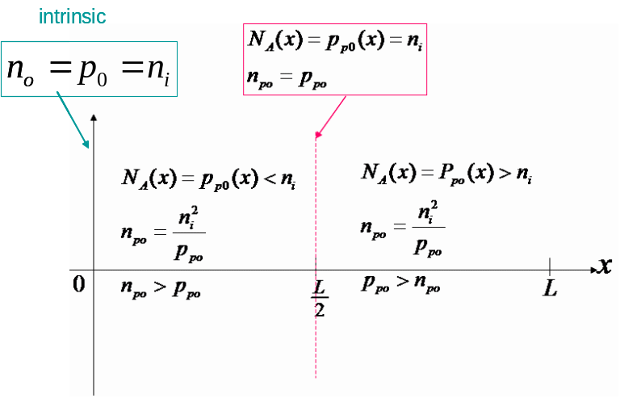

The electric field vector is 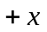 0→L
- In which direction does the electron diffusion current flow?
The electron diffuse from left to right, so the electron diffusion current direction is .
- In which direction does the hole drift current flow?
The hole drift current direction has to be the direction of the electric field. The answer is
- In which direction does the electron drift current flow?
The electron drift current direction has to be the direction of the electric field. The answer is
- Where is the electrostatic potential the greatest?
The electrostatic potential is greatest at , since the electric field is positive everywhere.
The answer is .
- In the axis provided below, sketch the volume charge density along x.
- In the axis provided below, sketch the electric field distribution along x.
- In the axis provided below, sketch the electrostatic potential 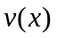distribution along x. Use as reference 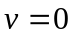 at 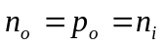.

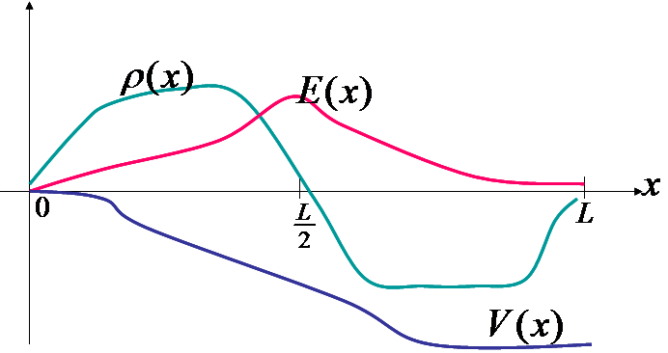

2. (10%) A silicon junction diode with 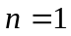has 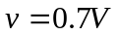, 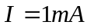 at 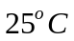. Find the voltage drop at 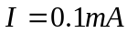and 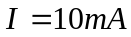.
Ans ： 